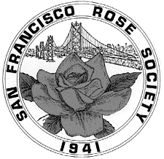


SAN FRANCISCO ROSE SOCIETY

invites you to
Listen to the Music

May 8, 2022
12:30 - 4:00 PM

At the
SAN FRANCISCO COUNTY FAIR BUILDING
NINTH and LINCOLN AVE.
San Francisco, CA
AARS Winners 2014 – 2003

2014 | Coretta Scott King | orange-pink | Grandiflora
2013 | Francis Meilland | light pink | Hybrid Tea
2012 | Sunshine Daydream | light yellow | Grandiflora
2011 | Dick Clark | red blend | Grandiflora
 | Walking on Sunshine | yellow | Floribunda
2010 | Easy Does It | orange-pink | Floribunda
2009 | Carefree Spirit | red-blend | Shrub
 | Cinco de Mayo | russet | Floribunda
 | Pink Promise | pink blend | Hybrid Tea
2008 | Dream Come True | yellow blend | Grandiflora
 | Mardi Gras | pink blend | Floribunda
2007 | Rainbow Knockout | light salmon | Shrub
 | Strike It Rich | gold blend | Grandiflora
 | Moondance | white | Floribunda
2006 | Wild Blue Yonder | lavender blend | Grandiflora
 | Julia Child | butter yellow | Floribunda
 | Tahitian Sunset | apricot blend | Hybrid Tea
 | Rainbow Sorbet | yellow-red bicolor | Floribunda
2005 | About Face | yellow blend | Grandflora
 | Day Dream | mauve blend | Shrub
 | Elle | pink | Hybrid Tea
 | Lady Elsie May | coral Pink | Shrub
2004 | Honey Perfume | apricot yellow | Floribunda
 | Memorial Day | lavender pink | Hybrid Tea
 | Day Breaker | yellow blend | Floribunda
2003 | Whisper | white | Hybrid Tea
 | Eureka | apricot blend | Floribunda
 | Hot Cocoa | russet blend | Floribunda
 | Cherry Parfait | red/white bicolor | Floribunda

AARS Winners 2002 – 1999

2002 | Starry Night | white | Shrub
 | Love and Peace | yellow-blend | Hybrid tea
2001 | Marmalade Skies | orange-blend | Floribunda
 | Glowing Peace | yellow-blend | Grandiflora
 | Sun Sprinkles | deep yellow | Miniature
2000 | Knock Out | red-blend | Shrub
 | Crimson Bouquet | dark red | Grandiflora
 | Gemini | coral pink-blend | Hybrid Tea
1999 | Betty Boop | yellow-blend | Floribunda
 | Fourth of July | red/white stripe | Climber
 | Candelabra | orange-blend | Grandiflora
 | Kaleidoscope | mauve-blend | Shrub

San Francisco County Fair Building

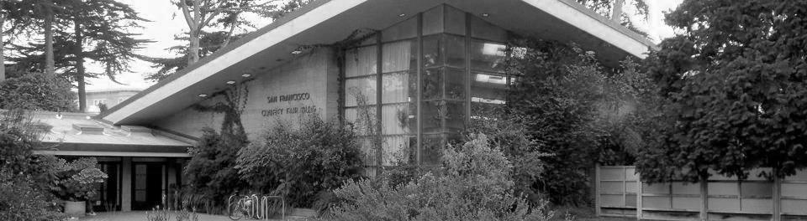

The San Francisco Rose Society

Wishes to thank our Sponsors,
Benefactors, our Judges and

Our Members

who brought roses to make
our Rose Show, and our World

BEAUTIFUL!

SAN FRANCISCO
ROSE SOCIETY

Annual Rose Show

May 8, 2022

“Listen To The Music”

TABLE OF CONTENTS

Schedule of Events 2

Society Officers 2

Show Committee and Judges 2-3

Trophy List 4

Show Rules 5-9

Show Schedule
Challenge Classes 10-15
Horticulture Specimen Classes 16-23
Arrangement Classes 25-30
Photography Classes 31-37
Judges Arrangements 38

SCHEDULE OF EVENTS

Show Entries 7:00 AM - 10:00 AM
Judging 10:15 AM - 12:00 PM
Show Opens to the Public 12:30 PM
Judges Luncheon 12:30 PM
Rose Show Closes 4:00 PM
SFRS Awards Ceremony, June 12, 2022 1:00 PM

SAN FRANCISCO
ROSE SOCIETY OFFICERS
President Kleyton Jones
1st Vice President Heather Dalloul
2nd Vice President Sherri Suto
Treasurer Maryanne Razzo
Secretary Rose Gilardi
Director Hilary Elkin
Publisher Maryanne Razzo
Editor Maryanne Razzo
Web Master Maryanne Razzo

ROSE SHOW COMMITTEE
Show Chair Maryanne Razzo
Judges Chair Rose Gilardi
Trophies/Awards Chair Maryanne Razzo
Clerks Chair Kleyton Jones/Sherri Suto
Tally Chair Leanna Lucchesi
Properties Chair Maryanne Razzo
Horticultural Schedule Rose Gilardi
Arrangement Schedule Rose Gilardi/Hilary Elkin
Photography Schedule Rose Gilardi

JUDGES FOR THE SHOW

Horticulture

Cheryl Frechette Healdsburg, CA
Lou Evens Livermore, CA
Martine LaBelle Richmond, CA
Betty Mott Mill Valley, CA
Dave Coop Roseville, CA
Sue Magill Roseville, CA
Michael Braun Ft. Worth, Texas
Karen Ernsberger Glen Ellen, CA
Eileen Jackson Vallejo, CA

Arrangements and Photography

Barbara Gordon Mountain View, CA
Donaldina Joung Tubac, AR



San Francisco Rose Society Perpetual
Trophies

Queen: Jack Halpern Trophy
Miniature Queen: SFRS Trophy
Miniature Sweepstakes: Kahman Trophy
Novice Sweepstakes: Mildred J. Butler Trophy
Amateur Sweepstakes: President’s Trophy
Best One Bloom Single or Semi-double Rose:
Bruce Phillips Trophy
Dowager Queen: Donaldina Joung Trophy
Best One Bloom per stem Grandiflora: Neick Trophy
Best Judges Entry: Keeper Trophy

Sweepstakes points are earned in the following manner:
1st place award | 5 points
2nd place award | 3 points
3rd place award | 2 points
Honorable Mention | 1 point
Any Queen | 5 points




ROSE SHOW RULES

- This show is organized and judged in accordance with the rules of the American Rose Society. This is an alphabetical show; horticulture entries in Specimen Horticulture Classes (Division I, Section B) will be made in alphabetical order with the first letter of the rose name determining placement in each class unless otherwise specified in this schedule.

- Only San Francisco Rose Society members may take possession of Perpetual Trophies. Multiple blue, red and yellow ribbons or dots may be given, but only one Best Entry will be chosen in each class or subclass where the entries merit them. Judges may withhold any of these awards at their discretion. The decisions of the Judges are final.

- The Show Chair will be responsible for interpreting the show schedule and enforcing the rules of the show.

- Sweepstakes Points will be awarded as follows:
Blue-5, Red-3 and Yellow (or Green)-1 point.
Queens merit an extra 5 points each.

All Exhibitors

- No exhibitor will be allowed to remain on the show floor when judging begins except those with specific assigned duties.

- Anyone is eligible to enter this show as long as the exhibitor grows the roses in their own private outdoor garden, except where stated in certain Arrangement Classes. All Horticulture entries become the property of the San Francisco Rose Society.

Horticulture Exhibits

- In all Horticulture Classes one person per garden is considered an exhibitor; two or more persons tending the same garden are considered an exhibiting team. Judges of this show may enter the Judges Class as individuals. Arrangements are considered an individual effort and each member of an exhibiting team may enter their own creations.

- Novices are urged to exhibit in all Divisions. A Novice is a person who has accumulated less than 50 points in an ARS sanctioned Rose Show and has not won the Novice Sweepstakes Award at an ARS sanctioned Rose Show. An Amateur is an exhibitor who has graduated from the Novice class having won more than 50 points as a Novice and/or has won the Novice Sweepstakes in an ARS sanctioned Rose Show.

- Novices must write “N” on their entry tags on the left upper corner on both the top portion and lower portion of the entry tag. Sweepstakes Points will be withheld if this designation does not appear on the entry tag. The Novice Sweepstake Trophy will only be awarded to the highest points accumulated by a Novice exhibitor with the “N” designation on their entry tag.

- All entries in multiple designations (Novice or Amateur) by any exhibitor will be disqualified.

- Entry tags must be complete; both the top and the bottom of the tag must be filled out. You must name each variety of rose used except as noted in this schedule. Tags must be folded so that the name of the exhibitor cannot be seen. Official ARS entry tags must be used. Challenge tags should be used for all Challenge Classes and Arrangement tags for Arrangement entries.

- No exhibits, entry tags, containers or awards may be removed before the close of the show except by the Show Committee.

- Only one entry per variety is allowed in Specimen classes but there is no limit to the number of different varieties that may be entered. Only three entries per class are allowed in Challenge Classes. Three different entries are allowed in each of the Judges Classes.

- Containers will be furnished according to availability for all Challenge, Horticulture and Judges Classes unless otherwise specified.

- Wedges are permitted but must not protrude above the lip of the vase. A protruding wedge will be penalized.

- Roses shown in one bloom per stem classes should be shown without side buds. These Classes include Hybrid Teas, Grandifloras, Floribundas, Climbers, Miniatures, Minifloras, and their climbing forms.

- All spray classes (inflorescence classes) must be shown with two or more blooms per stem. A bud is NOT considered a bloom.

- Shrubs and Old Garden Roses may be shown as Sprays or as One Bloom per Stem, whichever makes the better exhibit.
19. All Roses are allowed to have ONE stem on stem condition (one year’s growth only). They may have one side bud but are subject to severe penalization in one-bloom classes.

Judging

- Rose types and exhibition names will be determined by Modern Roses internet data base and supplements, The American Rose Annual, the ARS Handbook for Selecting Roses, the ARS Official List of Approved Exhibition Names, the List of Recently Registered Roses on the ARS website, and The Combined Rose List. Details, especially of Old Garden Roses prior to 1867, should be double-checked in the Modern Roses database.

- Specimens will be judged in accordance with the latest ARS Guidelines and Rules for Judging Roses. Arrangements will be judged in accordance with the latest ARS Guidelines for Judging Rose Arrangements.

- Horticulture entries will be disqualified for:
a. Misnamed - if the rose is not the variety listed on the entry tag
b. Exhibitor’s name visible on the entry tag if not corrected before the entry is judged.
- Any foreign substance applied to the stem, foliage or bloom to improve the appearance of the entry.
- A challenge class entry that does not satisfy the requirements of the class in which it is entered.
- Any entry not grown outdoors and/or not grown by the exhibitor.

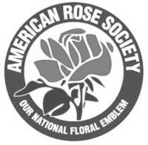

DIVISION I HORTICULTURE

SECTION A CHALLENGE CLASSES
Only members of SFRS may take possession of the Trophies awarded.

All varieties must be identified on the entry tag. Containers will be furnished unless otherwise specified.
Limit to three entries in each class per exhibitor in
Section A

Class A George F. McDonough Trophy
Five Hybrid Tea or Grandiflora roses without side buds:
One each: White, Red, Pink, Yellow and Any Blend. Each in a separate container, all correctly labeled. Each rose must have its own entry tag attached.
Roses must have been grown in San Francisco by members of SFRS.
Society containers must be used. Judged as one exhibit.

Class B Mrs. Jack Halpern Trophy: A Pair of Queens
Any two (2) Hybrid Tea or Grandiflora, without side buds, shown in the same container. Exhibition stage. Only Roses selected from the list of Queens are eligible.
Entries are limited only to:
Black Magic, Opening Night, Whisper, Magic Lantern, Tahitian Sunset, Lynn Anderson, Artistry, Marilyn Monroe, Gemini, Chris Evert.

Class C Emma (Andy) Kays Trophy:
Two mauve or mauve blend roses displayed in separate containers. One without side buds and one spray (a spray must have two or more blooms).
Each rose must have its own entry tag attached.
Society containers must be used.

Class D Werner Koch Trophy:
One Peace Rose, or any other HT with Peace in its name, without side buds.
Society containers must be used.

Class E Charlotte Levy Trophy - Most Fragrant Rose One stem entry, one bloom per stem, any type rose. Fragrance counts 100%.
Society Containers must be used.

Class F Charles Cochran Trophy: Boutonniere
One Floribunda or Miniflora bloom without foliage, not to exceed 3” overall.
Not a bud but at pre-exhibition stage, (petals unfurling but not yet in exhibition stage).
Lapel board provided by the Society.

Class 1 Miniature Boutonniere
One Miniature bloom only without foliage, not to exceed 1 ½” overall.
Not a bud but at pre-exhibition stage, (petals unfurling but not yet in exhibition stage). Lapel board provided by the Society. Certificate

Class 2 Rose in a Frame - Large
One bloom per stem, any large-flowered variety (not Mini/Polyantha/ Miniflora) exhibited in an orchid tube attached to a dark background in a picture frame provided by the Society on a first come basis. Exhibitor’s own frame may be used. No foliage. Certificate.

Class 3 Rose in a Frame - Small
One bloom per stem, any Miniature, Miniflora or Polyantha exhibited in an orchid tube attached to a dark background in a picture frame provided by the Society on a first come basis. Exhibitor’s own frame may be used. No foliage. Certificate.

Class 4 Large English Box - Hybrid Tea/Grandiflora roses. Exhibition stage. Same or mixed varieties. No stem or foliage visible. Society box subject to availability. Exhibitor’s own box may be used. ARS Certificate.

Class 5 Small English Box - Miniature/Miniflora roses. Exhibition stage. Same or mixed varieties. No stem or foliage visible. Society box subject to availability. Exhibitor’s own box may be used. ARS Certificate.

Class 6 Large Exhibition Floating Rose - Hybrid Tea/ Grandiflora. Entry must float in a colorless container of clear water. Bloom exhibited without foliage and must be in proportion to size of container. Exhibition form. Container provided by exhibitor. ARS Certificate.

Class 7 Small Exhibition Floating Rose - Miniature/ Miniflora. Entry must float in a colorless container of clear water. Bloom exhibited without foliage and must be in proportion to size of container. Exhibition form. Container provided by exhibitor. ARS Certificate

Class 8 Decorative Floating Rose - Shrub/Floribunda/ Climber/Polyantha. Entry must float in a colorless container of clear water. Bloom exhibited without foliage and must be in proportion to size of container. Decorative form, NOT exhibition form or fully open. NO singles (4-8 petals). Bowl provided by exhibitor. Certificate

Class 9 Fully Open Floating Rose:
Any Rose fully open. Stamens must show.
Entry must float in a colorless container. Blooms must be exhibited without foliage and must be in proportion to size of container.
Container provided by the exhibitor. Certificate

Class 10 Old Garden Rose Bowl - Entry must float in a colorless container of clear water. Bloom exhibited without foliage and must be in proportion to size of container. Bowl provided by exhibitor. Certificate.

Class 11 Three Floating Roses in the Same Container:
Any type rose.
Same or different varieties. Exhibition or Decorative form. Roses must float in the same colorless container. Exhibited without foliage. Blooms must be in proportion to size of container. Container provided by the exhibitor.
Certificate

Class 12 Large Stages of Bloom -
Klima Challenge Class
Three stems, without side buds, same variety, HT or Grandiflora. One bloom fully open with stamens showing, one bloom at exhibition stage, and one bud with sepals down and petals beginning to unfurl. Exhibited in separate containers each with its own entry tag. Society containers must be used.
Certificate
Class 13 Small Stages of Bloom – Small roses (miniatures, minifloras or Polyanthas).
Three stems, without side buds, same variety, exhibited in separate containers. One bloom fully open with stamens showing, one bloom at exhibition stage and one bud with sepals down and petals beginning to unfurl. Certificate.

Class 14 Matching Pair of Mini or Miniflora Roses:
Two Miniature or Miniflora roses, without side buds, same variety, correctly named, exhibited in one container. Certificate

Class 15 Trailing Rose - One spray of a rose that blooms on short laterals (any variety). Exhibited in a floral tube, lying on a dinner napkin or velvet cloth of appropriate size. Cloth and tube provided by exhibitor. Certificate.

Class 16 Hi-Lo Roses - Two matched exhibition blooms. One a Hybrid Tea, Grandiflora or Floribunda, one a Miniature or Miniflora. Exhibited in separate containers each with a separate entry tag. The small rose must be staged directly in front of the large rose. Judged as one exhibit. ARS Certificate.

Class 17 Mini Rose Bouquet - a bouquet of 5 or more blooms, at least 5 stems, miniature and/or miniflora roses, same or different varieties, in one clear container provided by the exhibitor. Certificate.

Class 18 AARS Rose - any AARS winner of the 15 years from 1999 – 2013, listed inside the front covers. Year of Award must be on the entry tag.
One bloom per stem or spray. Certificate.

Class 19 Blackest Red Rose – Any Rose – the darkest rose you grow, any variety, one bloom per stem or spray. Certificate

Class 20 Striped Rose – Any striped rose, any variety, one bloom per stem or spray. Certificate

Class 21 Largest Rose – The largest rose you grow, one bloom per stem or spray. Certificate

Class 22 Smallest Rose – The smallest rose you grow, one bloom per stem or spray. Certificate

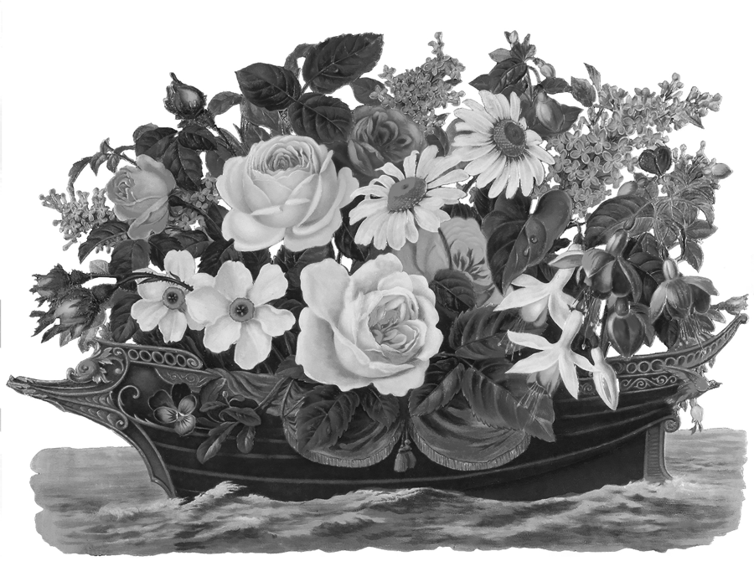

SECTION B

HORTICULTURE SPECIMEN CLASSES

OFFICIAL SCORECARD FOR
HORTICULTURE CLASSES
IN AMERICAN ROSE SOCIETY ROSE SHOWS
Form | 25 points
Color | 20 points
Substance | 15 points
Stem & Foliage | 20 points
Balance & Proportion | 10 points
Size | 10 points
TOTAL | 100 points

Novices must follow Rule 9 on page 7

HYBRID TEAS, GRANDIFLORAS
AND THEIR CLIMBING FORMS

Class 100 Hybrid Tea or Grandiflora, one bloom per stem, without side buds, exhibition form. Cultivars with 4 to 8 petals (singles) not eligible.
Queen of Show ARS Certificate
King of Show ARS Certificate
Princess of Show ARS Certificate
Court of Honor Certificate

Class 101 Three stems Hybrid Tea or Grandiflora, one bloom per stem, without side buds. Same variety, exhibition form. Cultivars with 4 to 8 petals (singles) not eligible. In one container.

Class 102 Hybrid Tea spray, one stem, two or more exhibition blooms on the stem.
ARS Certificate.

Class 103 Grandiflora spray, one stem, two or more exhibition blooms on the stem.
ARS Certificate.

Class 104 Three Hybrid Tea or Grandiflora sprays, two or more exhibition blooms per stem.
In one container.

Class 105 Single Hybrid Tea or Grandiflora one bloom per stem or spray, one stem,
(a single rose has 4 to 8 petals.)
Certificate.

Class 106 Fully open Hybrid Tea or Grandiflora bloom (stamens must show),
ARS Fully Open HT Certificate.
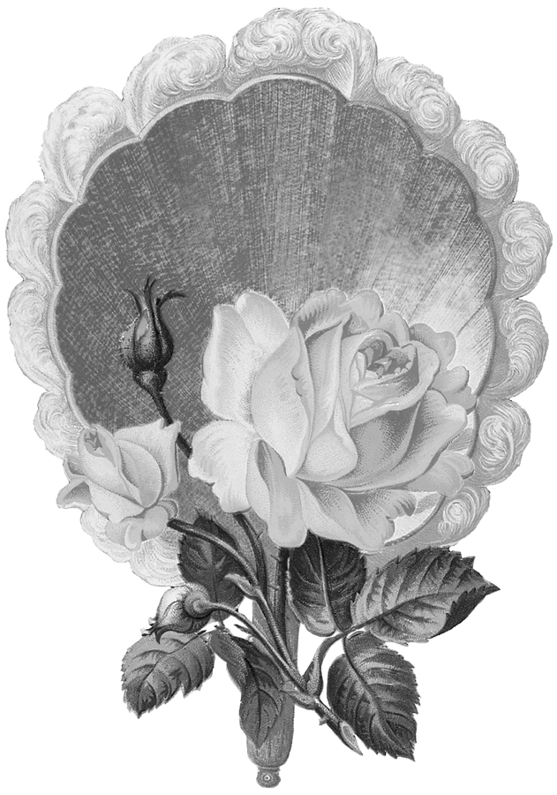

FLORIBUNDAS
AND THEIR CLIMBING FORMS

Class 200 One bloom per stem, without side buds.
ARS Certificate.

Class 201 One stem spray, two or more blooms per stem. Form typical of the variety.
Fl. Spray Queen ARS Certificate
Fl. Spray King ARS Certificate
Fl. Spray Princess ARS Certificate
Court of Honor Certificate

Class 202 One Bloom Fully Open, without side buds, stamens must show. Certificate.

Class 203 Three sprays, same variety or mixed, in one container.

POLYANTHAS
Class 300 One stem. Naturally grown spray, two or more blooms per stem.
ARS Certificate.

Class 301 Three Sprays, two or more blooms per stem, same or different varieties. In one container.

LIGHTLY PETALLED ROSES
Single and Semi-Double Roses
(Single – 4-8 petals)
(Semi-Double – 9-16 petals)

Class 305 One bloom per stem, without side buds.
Bruce Phillips Trophy

Class 306 One spray, two or more blooms per stem.

MINIATURE ROSES
AND THEIR CLIMBING FORMS

Class 400 Miniature, One bloom per stem, exhibition form, no side buds. Cultivars with 4 to 8 petals (singles) are not eligible.
Miniature Queen of Show - ARS Certificate
Miniature King of Show - ARS Certificate
Miniature Princess of Show - ARS Certificate
Miniature Court of Honor Certificate

Class 401 Miniature, three stems, one bloom per stem,
exhibition form, same or different varieties. Single cultivars with 4-8 petals are not eligible. In one container.

Class 402 Miniature Spray, one stem, two or more blooms per stem. Single cultivars with 4 to 8 petals are not eligible.

Class 403 Miniature Spray, three stems, two or more blooms per stem, same or different varieties. In one container.

Class 404 Miniature, fully open, without side buds, stamens must show, ARS Certificate

Class 405 Miniature Single, one bloom per stem. A
single rose has 4 to 8 petals. ARS Certificate.

Class 406 Miniature Spray, single, two or more blooms per stem. A single rose has 4 to 8 petals.

Class 407 Miniature, single (4-8 petals),three stems, one bloom per stem or spray. Same or different varieties. In one container.
ARS Miniature Spray Certificate chosen from
Classes 402 & 406
MINIFLORA ROSES
AND THEIR CLIMBING FORMS

Class 500 Miniflora, one bloom per stem, exhibition form, no side buds. Cultivars with 4 to 8 petals (singles) are not eligible.
Miniflora Queen of Show - ARS Certificate
Miniflora King of Show - ARS Certificate
Miniflora Princess of Show - ARS Certificate
Miniflora Court of Honor Certificate

Class 501 Miniflora, three stems, one bloom per stem, exhibition form, same or different varieties. Single cultivars with 4-8 petals are not eligible. In one Container.

Class 502 Miniflora Spray, one stem, 2 or more blooms per stem. Cultivars with 4 to 8 petals (singles) are not eligible.

Class 503 Miniflora Spray, three stems, 2 or more blooms per stem, same or different varieties.
In one Container.

Class 504 Miniflora, fully open, without side buds, stamens must show. ARS Certificate.

Class 505 Miniflora single, one bloom per stem.
A single rose has 4 to 8 petals.
ARS Certificate.

Class 506 Miniflora, single, one stem spray. Two or more blooms per stem. A single rose has 4 to 8 petals.

ARS Miniflora Spray Certificate chosen from
Classes 502 & 506

LARGE-FLOWERED CLIMBERS
(LCl, Hybrid Wichurana, Hybrid Gigantea)

Class 600 One stem, one bloom per stem, without side buds, or one spray, two or more blooms per stem. ARS Certificate

Class 601 Three stems, one bloom or spray, same or different varieties. In one container.

SHRUBS

Spray or one bloom per stem, whichever makes the better exhibit. May be exhibited stem-on-stem (one year’s growth).

Classic Shrubs.

Class 700 Classic Shrub - One bloom per stem or spray. Only Hybrid Rugosa, Kordesii, Hybrid Moyesii, Hybrid Musk and Ramblers
are eligible in this class. ARS Certificate.

Modern Shrubs
Marked “S” in the Handbook for Selecting Roses.

Class 701 Shrubs including Austin Shrub Roses (S) One bloom per stem or spray.

ARS Shrub Certificate chosen from class 701

Class 702 Any Shrub Rose- three stems, one bloom per stem or spray. Austin or modern shrub, same or mixed. In one container.

OLD GARDEN ROSES

Old Garden Roses are classes of roses established prior to the introduction date of the Hybrid Tea ‘La France’ in 1867. At least one cultivar in each class dates to before 1867. The cultivars themselves are of mixed or unknown
dates. There are two sections. See the latest Handbook for Selecting Roses or Modern Roses data base for detailed information. Stage all varieties in alphabetical order, regardless of family.

CULTIVARS INTRODUCED BEFORE 1867

Class 801 One stem, one bloom or one spray.
Species cultivars not eligible.
Joung Trophy and ARS Dowager Certificate.

Class 802 Three stems, one bloom or spray, one or different cultivars.
Species cultivars not eligible.

CULTIVARS INTRODUCED 1867 & AFTER

Class 803 One stem, one bloom or one spray.
Species cultivars not eligible.
ARS Victorian Rose Certificate.
Class 804 Three stems, one bloom or spray, one or different cultivars. Species cultivars not eligible.

SPECIES ROSES
(Marked “SP” in the Handbook for Selecting Roses)

Class 900 One stem, one bloom or spray.
ARS Genesis Certificate

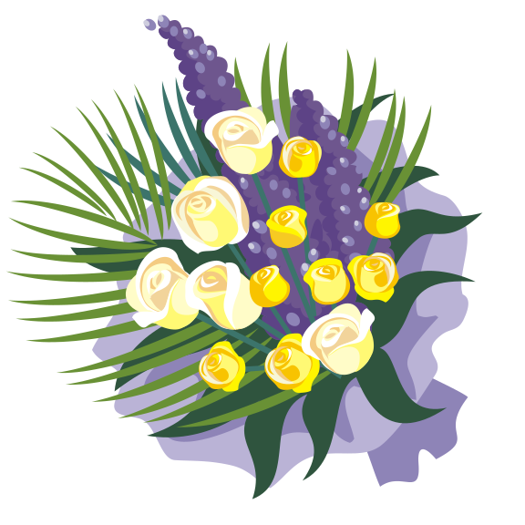
JUDGES INVITATIONAL CLASS

Judges for this show are allowed three entries in each Class, each of a different variety.

Class J-1 Hybrid Tea/Grandiflora One bloom per stem, without side buds, exhibition form.

Class J-2 Shrub/Climber One bloom per stem or spray.

Class J-3 Floribunda One bloom per stem or spray.

Class J-4 Miniature / Miniflora One bloom per stem, without side buds, exhibition form.

Class J-5 Miniature / Miniflora Spray
One stem spray.

Class J-6 OGR One bloom per stem or spray, date of
origin may appear on entry tag.

Class J-7 Any Other Rose Variety Not Listed
One bloom per stem or spray.

Best Judge’s Entry: ARS Certificate and
Keeper Trophy



DIVISION II ROSE ARRANGEMENTS
DIVISION II ROSE ARRANGEMENTS

“Listen To The Music”

SECTION A
MINIATURE ROSE ARRANGEMENTS
Miniature and Miniflora Rose Arrangements are eligible for the ARS Mini Gold, Silver, and Bronze Certificates if they score 92 points or more and are arranger-grown with “AG” marked on the entry tag.

Class 1 A Rose is Still a Rose: A modern miniature design, no more than 8 inches in height, width and depth.
Miniature roses only, accessories permitted.

Class 2 La Vie en Rose: Choice of arrangement, no more than 10 inches in height, width and depth. Miniature or Miniflora roses only.

Best entry of Class 1 and 2 are eligible for the
ARS Miniature Artist Award.

SECTION B
STANDARD ROSE ARRANGEMENTS
Standard Rose Arrangements in Section B (Classes 3-7) are eligible for the ARS Gold, Silver, and Bronze Certificates if they score 92 points or more and are arranger-grown with “AG” marked on the entry tag.

Traditional Design

Class 3 Mother Rose: A mass design.
Class 4 Ramblin’ Rose: A traditional mass or
line-mass design. Accessories permitted

Best of Class 3 and 4 are eligible for the
ARS Royalty Award.
Modern Design

Class 5 Rose of My Heart: A modern arrangement.
Arranger’s Choice of modern design. State the design style on the entry tag.

Class 6 Every Rose has its Thorn: A modern abstract design using only fresh roses and foliage, rose hips, canes and/or roots. Show stages of bloom. No other plant material or accessories allowed.

Best of Classes 5 & 6 eligible for the ARS Artist Award
Best of Class 6 eligible for the ARS Princess Award

Oriental Manner

Class 7 For the Roses: A design with an oriental flair. Arranger’s Choice of design style in the oriental manner.
Best of Class 7 eligible for ARS Oriental Award.

NOVICE ARRANGERS ONLY
Those who have won fewer than 3 blue ribbons in the Arrangement Sections.

Class 8 The Days of Wine and Roses: Arranger’s choice of design, Roses must be dominant. State the design style on the entry tag.

Best of Class 8 eligible for a Show Certificate.
SECTION C

JUDGES SPECIAL CLASS

Class 9 Love is the Rose: An arrangement of your choice. State the design style on the entry tag.

Best of Class 9: Eligible for the ARS Best Judge‘s Certificate.

OFFICIAL SCORE CARD
FOR ROSE ARRANGEMENT CLASSES
IN AMERICAN ROSE SOCIETY ROSE SHOWS
Conformance: (5 points per Category) a. Naming of Roses,  b. Conformance to Type of Design  c. Other specific Requirements of Schedule | 15 points
Design: (5 Points per Principle)  Balance, rhythm, dominance, contrast, proportion and scale | 30 points
Perfection of the Roses:  Including condition of other plant materials | 30 points
Creativity and Expressiveness: Imagination, creative handling in use of materials | 15 points
Distinction: Uniqueness, sets the design apart, Superiority in every aspect – including technical execution/construction | 10 points
TOTAL | 100

Arrangement Rose Show Rules

By entering this show under the ARS rules, exhibitors agree to abide by those rules.
All table coverings are white

1.All roses must be out door garden grown and must be of high quality.
2.Roses must be the dominant flower in all arrangements.
3.The ARS Approved Exhibition Name of all roses in each arrangement must be written on the entry tag.
4.“AG” must be noted on the entry tag if roses are arranger-grown so entries will be eligible for ARS Medal Certificates and Awards.
5.One entry per exhibitor is allowed in each class, but an exhibitor may enter as many classes as desired. More than one exhibitor from the same garden may enter the same class.
6.Accessories are allowed unless stated otherwise in the schedule.
7.Flowers other than roses, and dried and /or treated dried plant material are allowed unless prohibited by the schedule.
8.A card of intent may be included with an arrangement as an explanation of the arranger’s interpretation of the theme or class title, unless the schedule specifically forbids it.
9.An arrangement incorrectly placed in a class will be judged in the class it is placed.
10.All entries must be the work of the exhibitor.
11.No one but the exhibitor may touch or move the arrangement. However, in special circumstances, if all efforts to locate the arranger have failed, the arrangement chairperson may carefully move an arrangement.

Infringement of the following rules will result in severe penalty.
1.Painted or dyed fresh plant materials and live creatures are not allowed.
2.The use of plant materials on the state or local conservation list is not permitted.
3.The American flag or flag of any country may not be in an arrangement as a decoration in any way.

There are two caused for disqualification for an arrangement:
1.Roses not grown outdoors.
2.Use of artificial plant material

“N” must be printed on the entry tag if you are competing as a Novice. Credit for Sweepstakes points will be withheld if this designation does not appear in the top portion and the lower portion of the entry tag. Novices may enter any class except Judges Classes.

All containers will be provided by the exhibitor and remain the property of the exhibitor. SFRS assume no responsibility for lost or stolen property.

All entries must be placed between 7:00 and 10:00 am and be promptly removed at 4:00 pm at the close of the show.

ARS Medal Certificates (Gold, Silver or Bronze) are only given to the blue ribbon entries that score a minimum of 92 points.

A winning entry must score at least 90 points to win a first place ribbon. Second place entries must score at least 85 points; third place should score at least 80 points.

30” W x 30” D of table space will be available to each entry unless otherwise noted in class descriptions. Where ‘Arranger’s Choice of Design Style’ is indicated, the style of design should be written on the entry tag.

Arrangement Section Awards:

Arrangement Sweepstakes – M/M Clarence Pichel

Amateur Sweepstakes - Potter Trophy

Best Arrangement in the Show – Classes 1-8 –
Boyle Trophy

Earl’s Challenge – most Creative in Classes 1-8 –
Earl Parson Plaque

Miniature Arrangement Classes 1 & 2 –
ARS Mini Artist’s Rosette

Traditional Arrangement Classes 3 & 4 –
ARS Royalty Rosette

Modern arrangement Classes 5 & 6 – ARS Artist Rosette
Class 6 - ARS Princess Rosette

Oriental Arrangement – Class 7 – ARS Oriental Rosette

Novice Arrangement – Class 8 – Show Certificate

Judges Arrangement – Class 9 – ARS Judge’s Certificate

The San Francisco Rose Societies wishes to thank our volunteers, our donors, and the ARS Judges who have worked so hard to make this unique show event such a success.

DIVISION III PHOTOGRAPHY SHOW

Rules and Information

This show is governed by the standard rules, regulations and guidelines of the American Rose Society.

1. Competition is open to all members of any NCNH District Rose Society. Only three (3) entries per class per exhibitor. Judges entries for this show have their own rules.

2. All roses shown in photography entries must have been grown in an outdoor garden.

3. A photograph may not be entered more than once. A photograph entered in more than one class will not be judged in any class.

4. Previous winning photographs, defined as First (1st) through Fourth (4th) place in the ARS Digital Photography Contest, ANY national photography contest, ANY NCNH district or local rose photography show, may not be entered in this show.

5. Photographs entered in Creative Interpretation and Macro may be in color, black & white, sepia, or a combination of color and black & white (selective colorization). All other photographs must be entered in color.

6. All photographs are to be matted.

7. Outside dimensions of the mat are to be 11”x14”. No larger or smaller. The orientation of the photo may be landscape or portrait.

8. Photographs may be no smaller than 5”x7” and no larger than 8”x10”. Nonstandard shapes to the mat opening (oval, diamond, triangle, etc.) are welcome as long as it conforms to the size of the photo and the size requirements of the mat.

9. Color of the mat is at the discretion of the exhibitor.

10. Each exhibit must have a horticultural entry tag completed with Class number, Rose name, (unless otherwise stated in the class), Photographers name, address, on top and bottom of the tag.

Place your entry tag on the upper left corner of the matted photograph, securely folded. Proper placement of the entry tag will determine proper orientation of each photograph for judging. The exhibitor may place nothing identifying the photographer on the front photograph.

11. “Best in Section” Certificates will be awarded in each Class.

12. All rights to the submitted photographs are retained by the owner of the photographs. However, by submitting a photograph to the contest, the exhibitor (1) warrants that he or she owns the copyrights of the submitted photograph and is not legally prohibited from submitting it to the contest, and (2) agrees to allow the SFRS to display the photo at this Rose Show and publish the photograph in the local Society’s or NCNH District’s newsletters.

Scorecard for the Prime Elements of Judging

CONFORMANCE ………………………5

SPECIFIC SECTION…………………….50

COMPOSITION.……………………...….15

TECHNIQUE…….……………………....15

DISTINCTION...…………………………15

TOTAL…………...……………………..100

CONFORMANCE – 5 points
This section is for following the rules of the written schedule and the rules of the classes in which the photograph has been entered.

SPECIFIC SECTION – 50 points
The Rose – When judging a photograph of a horticultural specimen, many of the rules that are used in the ARS Guidelines & Rules for Judging Roses would be utilized.

The Rose Arrangement – When judging a photograph of a rose arrangement, the rules that are used in the ARS Guidelines for Judging Rose Arrangements would be utilized.

The Rose Garden – Rose Garden Photographs should show the use of roses within the structure of a garden, which can be widely variable. Roses should dominate in the photograph, and some layout of the garden should be visible. The name of a public garden MUST be listed on the entry tag; a private garden need not be named.
Creative Interpretation – The photograph should demonstrate originality and creativity. This may include processes to alter the original image such as colorizing, texturing, dodging, burning, dithering, painting, shadowing, blurring, layering, cloning, filtering, merging cropping etc. Composites, portions of roses, and roses with petals cut off are allowed in this class. Cameraless photographic techniques such as scanning may be included in this class. Color, Black & White, Sepia, or combinations of these are permitted in this class. Photo enhancement software is permitted in this class. The photographer is allowed and encouraged to utilize the full range of tools and processes to express his or her version in the creation of rose art.

COMPOSITION – 15 points
This area includes the point of interest, simplicity, color quality, contrast, and balance, framing the subject, viewpoint, direction of movement and diagonals where applicable. The point of interest in this case should be the rose.

TECHNIQUE – 15 points
The area includes correct exposure, depth of field, lighting and other relevant technical factors. Focus is often used by the photographer to provide a realistic effect that makes the viewer feel that he or she can reach out and touch the “real thing” in the photograph.

DISTINCTION – 15 points
Distinction indicates that everything about the photograph is well done, but in addition, there is something about this photograph that sets it apart from others in its class. Something that at first may be intangible – something we may call the “wow” factor.

SECTION X
Class 1 –
Theme of the Show: “Listen to the Music”
A photograph of any rose or roses that best interprets the theme of the show. Roses must be the dominant factor.
Award for Best of Class

SECTION Y

CLASS 2 – One Bloom.
One bloom, any type of rose classification. Single roses (4-8 petals) must be entered in Class 4.
Award for Best of Class

CLASS 3 – One Spray.
Two or more blooms, any type of rose classification.
This class does not include collections.
Award for Best of Class

CLASS 4 – Fully Open Bloom.
One bloom, stamens must show, any variety, singles (4-8 petals) ARE permitted.
Award for Best of Class

CLASS 5 – Rose Potpourri
A horticultural specimen that does not fit the criteria for classes 2-4. For example – rose hips, foliage, seedlings, critters in the garden, portion of a rose bush with companion plants, etc.
Award for Best of Class

CLASS 6 – Arrangements
Traditional, Modern or in the Oriental Manner
A photo of a traditional or modern arrangement, miniature or standard, following the ARS Guidelines for Judging Rose Arrangements. Arranger’s name MUST be indicated.
Award for Best of Class

CLASS 7 – Macro Photography
Photographs should be extreme close-up photo of any part of the rose or rose plant.
Color, Black & White, Sepia, or combinations of these are permitted in this class.
Award for Best of Class

Class 8 – Creative Interpretation
The photograph should evoke a sense of originality and a new and different way of imagining the rose or roses with the mind’s eye. This may include processes used to alter the original image such as colorizing, texturizing, dodging, burning, dithering, painting, shadowing, blurring, layering, cloning, filtering, merging, cropping. Color, Black & White, Sepia or combinations of these are permitted in this class. Photo enhancement software is permitted in this class.
Award for Best of Class

Class 9 – A Rose Garden
The photograph should show the use of roses within the structure of a garden, which can be widely variable. Roses should dominate in the photograph, and some layout of the garden should be visible. Private gardens need not be identified. Public gardens MUST be identified by name on the entry tag.
Award for Best of Class

SECTION Z

Judges classes
This section is open to all the judges (including their immediate families) who are judging this show including the photography section of the show. Winners are not eligible for the court. A special panel of judges will judge this section. Only two entries per class.
Award for Best Judges Entry

Class 10 – The Rose
A photograph of any rose or roses.
Award for Best of Class

Class 11 – The Rose Arrangement
Type of arrangement (traditional, modern or Oriental manner). Arranger’s name MUST be noted on the entry tag.
Award of Best of Class

Class 12 – Rose Art
Creative interpretation of any rose or roses (see Class 8 above for suggestions).
Award for Best of Class

Class 13 – The Rose Garden
Private gardens need not be identified. Public gardens MUST be identified by name on the entry tag.
Award for Best of Class

Class 14 – Rose Potpourri
(See Class 5 above for suggestions).
Award for Best of Class

NOTES:

